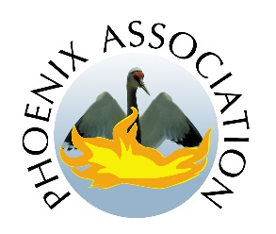
Phoenix Association
…caring for and rehoming animals in need

Application for COUNCILLOR positions

Members of the “Conseil d’Administration” (Council) look after the management and policy development of the Association.

In addition to the Ordinary General Meeting (sometimes referred to as the AGM), the Council convenes for regular meetings throughout the year to discuss the situation of the Association and take actions to further its animal welfare work and to ensure the financial security of the Association. A minimum of four meetings must be held each year but are often convened more frequently.

The councillors should be committed to the association, passionate about helping animals, be good team players, enthusiastic, computer literate, to be able to maintain appropriate records. It is preferable have a basic knowledge of French.

Council posts are non-remunerated.

The activities of the seven Council positions at present cover the following roles.

- PRESIDENT 2. TREASURER 3. SECRETARY

The following tasks are currently managed between the other Councillors, often with the assistance of members who are not councillors.

* Animal Welfare Dogs and Foster Carers * Animal Welfare Cats and Foster Carers *
*Feline Sterilisation Programme * Communications * Website * Social Media Websites *
*Special Appeals * Membership * Fundraising * Events * Helpline *

Candidates are asked to complete the application form and write their Letter of Motivation
(no more than one side of A4 please).

Your Letter of Motivation will be circulated to the membership prior to the elections.

Closing date for applications will be Monday 8 April 2024

APPLICATION FORM COUNCILLOR POSITIONS 2020

Closing date: Monday 8 April 2024

Name of applicant:
Address:
Line 2:
Line 3:
Telephone number:
Email address:

Council activities that interest you:

Signed: Date:

Please return by attachment including your letter of motivation to:
The Secretary to the Conseil
email: phoenix24.members@gmail.com

Name:

Letter of Motivation:

